Be a Friend and Feel the Benefits!
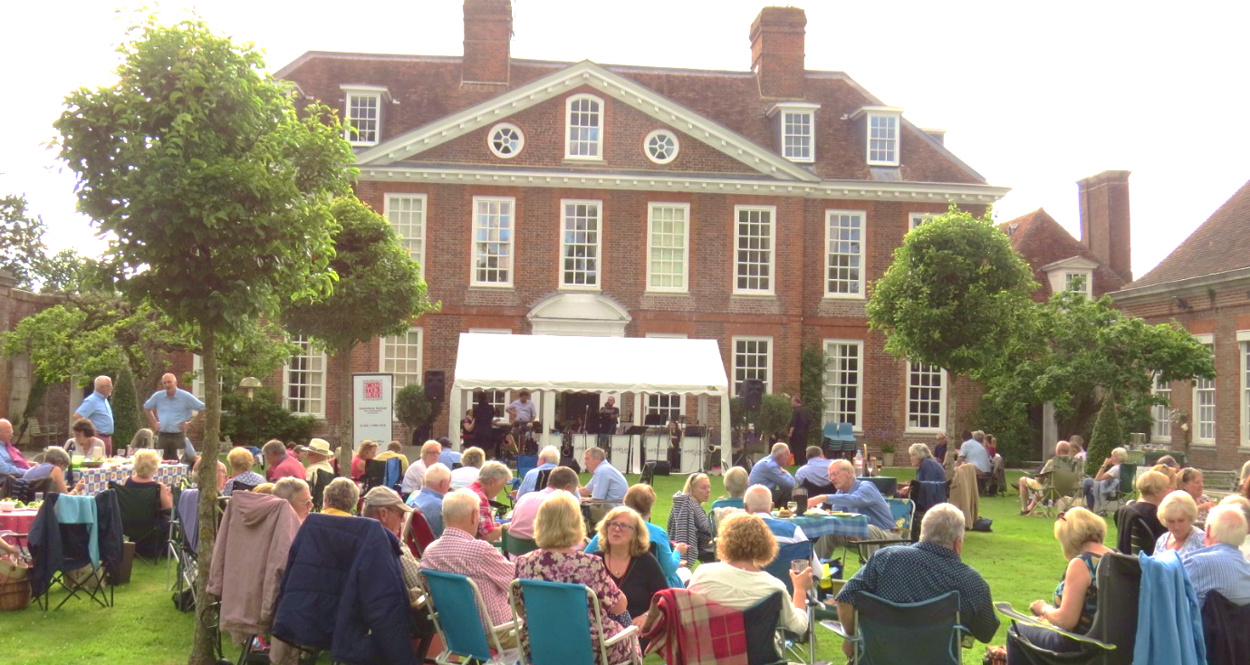
The Festival Friends were formed to support the Canterbury Festival and reward its loyal followers with some unique benefits. For as little as £25 per year Friends receive:
- Two exclusive weeks of priority booking for all Festival events before booking opens to the general public.
- Discounts on selected Festival events.
- Special offers and last minute deals.
- Twice yearly newsletters with previews of the Festival.
- A full social programme of Friends' events organised throughout the year.
- Listing in the Festival Concert Programme and on the Festival website.
We also have special Silver and Gold memberships which
offer even greater benefits.

For more information go to www.canterburyfestival.co.uk and click on the Friends pages or contact Tina at the Festival Office, 8 Orange Street, Canterbury, CT1 2JA, 01227 452853 or email tina@canterburyfestival.co.uk.
RENEWAL FORM
Membership Number: _________________________________________________________________
Name: __________________________________________________________________________________
Address: ________________________________________________________________________________
__________________________________________________________________________________________
Postcode: __________________________________ Telephone No:____________________________
Email: _____________________________________ Mobile No: ________________________________
Signed: _____________________________________________________ Date: _____/______/________
Please state exactly how you would like your name to appear in
Festival Publications: _________________________________________________________________

TICK | MEMBERSHIP TYPE
 | Single £25.00
 | Couple £35.00
 | Family £40.00
 | Silver £100.00
 | Gold £300.00
To pay your subscription please:
- Send a cheque made payable to Canterbury Festival Foundation (Friends)
- Return the enclosed Standing Order form
- Make a BACS payment to Sort Code 60-04-27 Account No. 90600967 and advise date payment made: _____/_____/________
Data Protection Regulations
- I agree to receive the Canterbury Festival brochure

and details of priority booking.

- I agree to receive communications from the Festival

Office regarding year-round events and ticket offers.
Please send this form with your cheque or Standing Order form, if appropriate, to: Tina Austen, Festival Office, 8 Orange Street, Canterbury, Kent, CT1 2JA or email to tina@canterburyfestival.co.uk

