Join the Friends and Feel the Benefits!
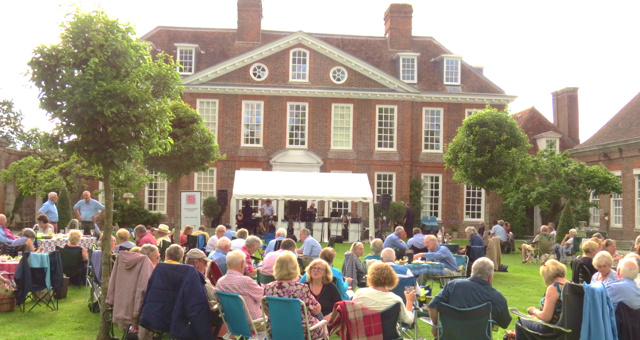
The Festival Friends were formed to support the Canterbury Festival and reward its loyal followers with some unique benefits. For as little as £25 per year Friends receive:
- Two exclusive weeks of priority booking for all Festival events before booking opens to the general public.
- Discounts on selected Festival events.
- Special offers and last minute deals.
- Twice yearly newsletters with previews of the Festival.
- A full social programme of Friends' events organised throughout the year.
- Listing in the Festival Concert Programme and on the Festival website.
We also have special Silver and Gold memberships which
offer even greater benefits.

For more information go to www.canterburyfestival.co.uk and click Become a Friend, contact Tina at the Festival Office, 8 Orange Street, Canterbury,
CT1 2JA, 01227 452853 or email tina@canterburyfestival.co.uk.
You may join the Friends on-line at the Festival Box Office: https://canterburyfestival.co.uk/support/festival-friends/ by telephone on 01227 457568, in person at the Festival Office or by completing and returning this form to the Festival Office, 8 Orange Street, Canterbury, CT1 2JA.

Title: ____________________________________________________________________
Name: __________________________________________________________________
Address: ________________________________________________________________
__________________________________________________________________________
Postcode:___________________ Telephone No:____________________________
Email: _______________________________ Mobile No: _______________________
Signed: ______________________________________ Date: _____/______/_______
Y/N

Do you wish your name to appear in any publications?

TICK | MEMBERSHIP TYPE
 | Single £25.00
 | Couple £35.00
 | Family £40.00
 | Silver £100.00
 | Gold £300.00
To pay your subscription you may:
- Pay by card on-line, over the telephone or in person at the Box Office
- Send a cheque made payable to Canterbury Festival Foundation (Friends)
- Request and complete a Standing Order form
- Set up a Direct Debit at Sort Code 60-04-27 Account No. 90600967 and advise date annual payments to be made: _____/_____/____. Please use your surname as reference.
- Make a BACS payment to Sort Code 60-04-27 Account No. 90600967 and advise date payment made: _____/_____/____. Please use your surname as reference.
Data Protection Regulations

I agree to receive the Canterbury Festival brochure
and details of priority booking.

I agree to receive communications from the Festival

Office regarding year-round events and ticket offers.

