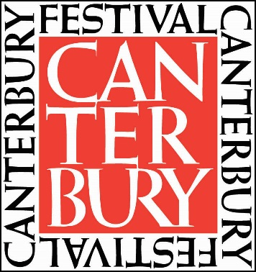

Schools’ Poetry Competition Entry Form 2024

Theme: COUNTING*

School Name:

Contact Teacher:

Contact Teacher email:

We are including: ……………………………………… number of pupils/poems.

Pupils names & age (add additional sheet if necessary):

I hereby declare that the poems submitted are the work of the pupils, as named on each submission.

Signed: (Teacher)

*The 2024 National Poetry Word is COUNTING. Poems need to be written with this theme in mind. Please ensure names and ages are clearly written on each poem. Only one entry form per class/school required.

Please return this form and entries in word format via email by

Friday 19 July 2024

Email: amandaseftonhogg@canterburyfestival.co.uk

Thank you for your support of the Schools’ Poetry Competition 2024
Prizes to be awarded
Gold, Silver and Bronze winners in four age categories:

Age 16 - 18: Gold=£50, Silver=£40, Bronze=£30

Age 12 - 15: Gold=£50, Silver=£40, Bronze=£30

Age 9 – 11: Gold=£40, Silver=£30, Bronze=£20

Age 5 - 8: Gold=£30, Silver=£25, Bronze=£15

Special Mentions will also be announced in each category.
Prizes will be awarded at the presentation showcase event on 3 October 2024.

Please ask the pupils to follow these guidelines – thank you!

Terms & Conditions of Entry:

- Each poem must be no more than 40 lines in length and writing should be legible
- Each poem to be loosely based on the theme which can be interpreted according to the entrant’s own choice
- Each poem must be on one side of A4, illustrations are welcomed
- No alterations can be made to the poem once submitted
- Each entrant should clearly write their name, age and school on the front of the poem
- The school should complete only one entry form for all the poems entered and send them as one batch to amandaseftonhogg@canterburyfestival.co.uk
- All submissions must be entrants’ own work and submitted by Friday 19 July 2024
- Entries must be written in clear English, not previously published or broadcast

Judging

- Shortlisted poems will be announced by mid-September through the named teacher contact.
- Shortlisted poets will be invited to read their poem in public at the Schools’ Poetry Competition Showcase on Thursday 3 October 2024, 5.30-6.30pm. Further details and information about this event will be sent directly to teachers nearer the event date.
- All shortlisted poems will be published in an anthology, copies will be provided to shortlisted poets and schools, who enter the competition.
- Copyright will remain with the entrant, but Canterbury Festival reserves the right to arrange the first publication or broadcast of selected poems, including possible reproduction on Stagecoach buses and in other Festival material.
- The judge’s decision is final.
- Submission of a poem implies the entrant’s acceptance of the above conditions.

Teaching resources available at
https://nationalpoetryday.co.uk/resources/
https://literacytrust.org.uk/resources/national-poetry-day-resources

